M10C AHD SD Card MDVR
User
Manual

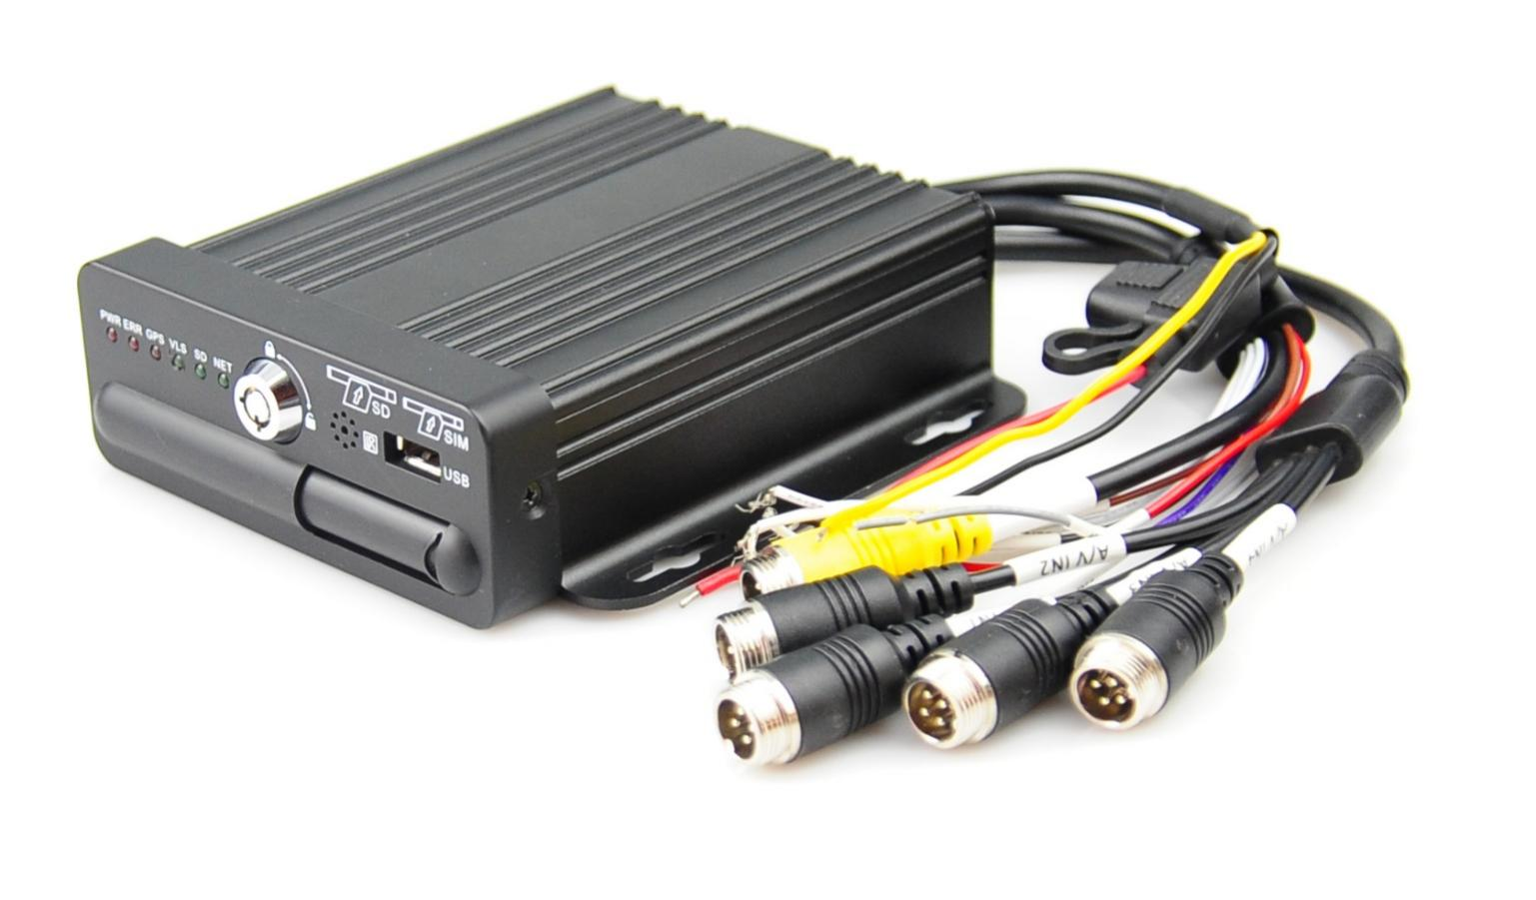

Content

1. Version Notes 4
2. Brief introduction 4
3. Product introduction 4
3.1 Product overview 4
3.2 Product features and functions 5
4. Equipment specifications 10
4.1 Front panel diagram 10
4.2 Back panel interface description 11
4.3 IO line definition specification 12
5. Equipment installation 14
5.1 Installation environment 14
5.2 Installation precautions 14
5.3 Check unpacking and accessories 17
5.4 The machine installation 17
5.5 Power cord connection 17
5.6 Alarm input connection 18
6. MDVR operation guide 19
6.1 Remote Controller 19
6.2 Real-time preview interface 20
6.3 Menu diagram 21
6.4 Login 21
6.5 Main Menu 22
6.6 Playback (secondary menu) 22
6.7 Pictures (secondary menu) 23
6.8 Settings (secondary menu) 23
6.8.1 Basic setup 23
6.9 Tools (secondary menu) 30
7. Answers to frequently asked questions 32

Security rules and instructions should be emphasized

！Notice:
Please read this manual carefully before first installation.
Secure this manual for future reference.

Please read the following warnings before installing and using this product:

1.Please handle with care during transportation.
2.All installation and maintenance must be performed by professionally trained and qualified personnel.
3.This product shall not be installed on the vehicle where it is subject to rain or other liquid erosion for a long time.
4.Installation method and all materials must be able to bear the weight of the body.
5.Keep the body away from heat, dust and strong magnetic field.
6.Heavy weights shall not be placed above the equipment and debris shall not be piled up within 50cm around
7.Do not flush the equipment directly when the vehicle is clean.
8.The output power supply of the equipment shall not be connected with any non-recommended device.
9.Do not attempt to insert fingers or foreign objects into the gaps in the equipment while it is running.
10.Do not open or remove the equipment without professional guidance.
11.No module shall be replaced when the main engine is live.

Preface

Version Notes
The corresponding product version of this manual is: M10C series AHD mini video recorder.

Brief introduction
This manual introduces an integrated with "4ch AHD 1080p AHD video and 4 g, GPS/BD in the integration of vehicle electronic equipment, model M10C features, specifications, describes in detail the function of each module of equipment and the use matters needing attention, describes in detail equipment connectors in the signal definition, detailed describes the equipment interface definition and the user operation.
The main contents of the book are divided into the following chapters:
3 Product introduction: briefly introduce product functions, main features and typical applications.
4 Equipment specifications: the overview, features, detailed specifications and precautions of each functional module are described in detail, including the monitoring video module and other functional modules, and the appearance of M10C is also described. Front and rear panel signal arrangement and connector definition; Definition of signals for each external cable.
5 Equipment installation: introduce the equipment installation and accessories.
6 Host operation guide: detailed introduction of the use of remote control, the function and use of each display menu.
7 Answers to frequently asked questions

Product introduction

3.1 Product overview
M10C is a multi-functional and flexible extension device specially developed for on-board and remote video monitoring. It is the M10H upgrade of our company. It adopts huawei Hess 3520D high-speed processing chip and stable embedded system, and USES advanced h.265 video compression/decompression technology, and mature 4G and GPS/BD reliable schemes. Vehicle driving information recording and remote video uploading, together with the scheduling and monitoring platform, can realize central remote video monitoring, intelligent vehicle scheduling management and playback analysis based on the central database. The product has the characteristics of small size, simple appearance, flexible installation, comprehensive function and high reliability. Detailed features are as follows:
- Industrial level design, vehicle-mounted special interface, to ensure the reliable and stable operation of products in complex environment;
- The latest audio and video compression technology;
- Supports 4 channels of video and 2 channels of audio storage;
- Professional and stable special file system;
- Extensible 4G, BD/GPS functional modules;
- Support for local and remote cradle head control;
- Support large capacity SD card storage;
- Support storage and data backup;
- Support UPS power supply endurance;
- Quick start-up;
- Support external printer, LED overhead light, fuel consumption, temperature sensor, etc;
- Support apple, android and other mobile terminal monitoring software;

3.2 Product features and functions

3.2.1 Product features
  - High performance huawei Hess CPU is adopted to make the system run faster and more stable.
  - Vehicle-mounted special interface, with good user experience.Video resolution is up to 1080P, using the latest h. 265 digital coding technology, high coding efficiency, flexible strategy.
  - It supports IR, and can do equipment parameter configuration, head control and other operations through the remote control.
  - The built-in pluggable 4G (WCDMA/EVDO/ td-lte/fdd-lte) module provides a flexible wireless transmission scheme.
  - The built-in high sensitivity satellite positioning module enables the positioning information to be synchronously sealed into the video stream.
  - The hardware is designed with power failure protection function. In case of sudden power failure, the device can enable the built-in supercapacitor to realize normal shutdown and effectively avoid the loss of critical data.
  - Built-in g-sensor acceleration sensor, adaptive installation position, no need to manually set, support driver driving behavior detection.
  - The use of on-board aviation plug to ensure the signal connection is stable.
  - With ignition start, delay shutdown (0 minutes ~24 hours) and 24 hours timing switch function.
  - Wide range power input (DC +8 ~ +36V) meets the requirements of automotive electrical characteristics.
  - All aluminum alloy housing, no fan design, with good cooling effect.

3.2.2 product function
Product details

Specification items |  | instructions
agreement |  | Support common video transmission and ministry of transportation standard JT808, JT1076, JT1078 protocol and other protocols
power input |  | Power input (DC+8V ~ 36V), in line with + 12/24v vehicle electrical requirements
Ignition signal (car key)
• < 8V, ignition signal off
• ≥8V, ignition signal on
Camera power supply (AV in1-avin4) |  | The output power of the camera is +12V, the output voltage is 12V (+/ -0.5v), and the maximum output current is 2A (with output overcurrent protection). The current of each camera cannot exceed 0.5a after the infrared switch on.
Monitor power supply (AVOUT) |  | Display power output, +12V (+/ -0.5v), the current of the screen does not exceed 0.5a.超过0.5A。
External device power output (DC OUT) |  | +12V, output voltage 12V (+/ -0.5v), maximum output current 1A
 |  | +5V, output voltage 5V (+/ -0.2v), maximum output current 1A
Power consumption |  | Maximum power consumption ≤16W
 |  | Standby power consumption is ≈0W
Video storage medium |  | SD card
Video | Video streaming standards | ISO 14496-10
 | Video input | Default 1 channel CVBS output 720P/25fps、4路D1/25fps
 | Video output | Default 1 channel CVBS output
 | Local video output display | Single screen, four screen can be matched
 | Video formats | PAL/NTSC format
 | Image compression standard | H. 264 Main Profile/h. 265
 | Image resolution | 1080 p / 720 p/D1 is optional
Audio | audio compression standard | The default is g. 726, and g. 711A is optional
 | Audio input | 2 channel analog audio input
 | Audio output | CVBS audio output
 | recording mode | Sound is recorded in sync with video
Power out protection | built-in UPS | Built-in 2x7F* 2.7v capacitor UPS, full charge in 1 minute. External power loss can maintain system work 2s to complete the system video, log and other important data preservation
I/O | I/O alarm input | 4 - channel I/O alarm input is supported  • high level alarm input value: 3.3 ~ 36V  • low level alarm input value: 0 ~ 3.3v
 | Switch volume alarm output | 1 way switch volume alarm output• the maximum switching capacity supports 12V@0.5A flow capacity.12V@0.5A的通流能力。
Communication interface | Serial interface | Support an RS232 interface
USB interface | USB2.0 | USB2.0 high-speed transmission
 | 4 g interface | All 4G systems of domestic operators such as tdd-lte/fdd-lte are by default, and foreign modules are optional
Other | operating temperature | -20 ~ +70°C (ambient temperature under well-ventilated conditions)
 | Working humidity | 8%-90% (no condensation)
 | Size appearance | Length 128.7mm X width 128.7mm X height 40mm
 | Weight | NW:0.5kg  GW:0.8kg(M10C-SGNE-L as a standard )

Product application solution
The application block diagram：
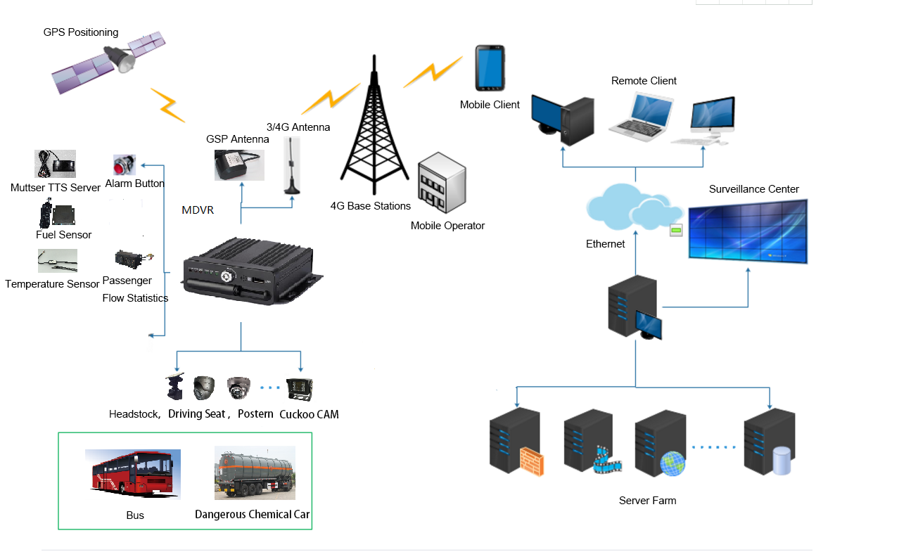

Application scenarios：
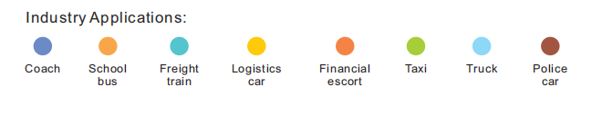

Product appearance interface description
size
The size and specification of M10C vehicle video recorder are shown in table 1-1
Device name | Length X width X height | Pin description
M10C MDVR | Length 128.7mm X width 128.7mm X height 40mm | The length, width and height here refer to the measurement of the front panel

The size of the host and the location of the mounting hole are shown in figure 2-2
Figure 1-1 size diagram of M10C vehicle video recorder

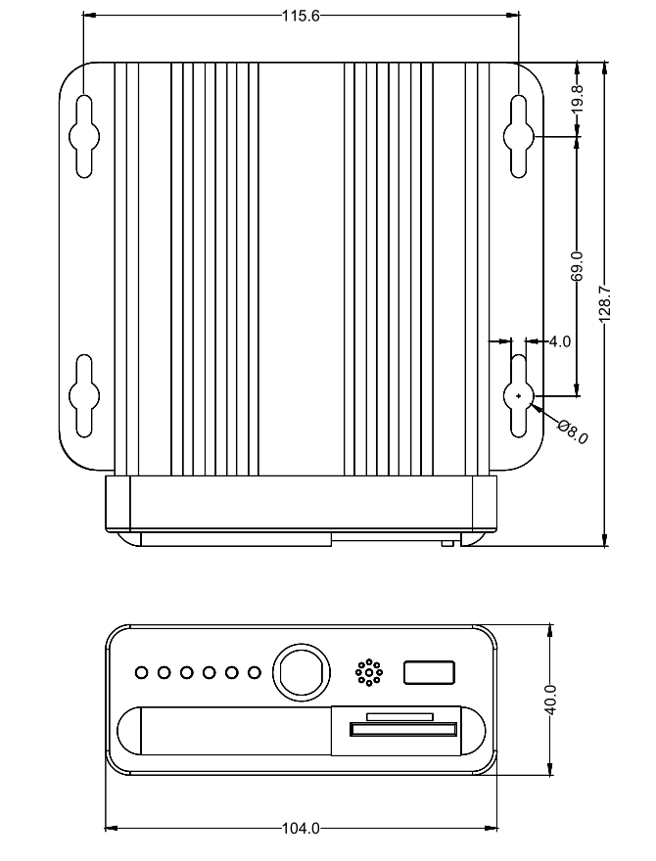

Equipment specifications

4.1 Front panel diagram
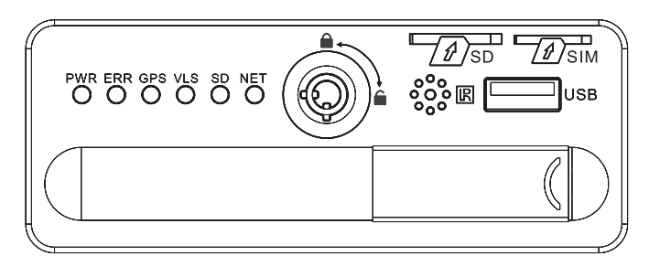
serial number | name | description
1 | SIM | SIM card slot
2 | SD | SD card slot
3 | USB | USB 2.0
4 | Lock | SD card lock with electronic lock function
5 | bin gate | Close and open the hatch to the right and left
6 | IR | Remote control receiving light
7 | PWR | Power input status indicator is always on
8 | ERR | Upgrade flicker in progress.
9 | GPS | GPS indicator light: steady light means GPS successfully, flashing means not，long off the indicator light means that the module does not exist
10 | VLS | Video loss always bright,
11 | SD | No recording is always on, video flicker is recording, indicator light is off SD card does not exist
12 | NET | Network light: The server is always on when the system is successfully registered, otherwise it blinks， long off the indicator light means that the module does not exist

Back panel interface description
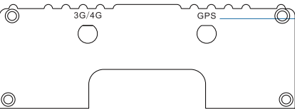

serial number | tag | instructions
1 | PWR-IN | Power input
2 | A/V IN1 | Video input channel 1
3 | A/V IN2 | Video input channel 2
4 | A/V IN3 | Video input channel 3
5 | A/V IN4 | Video input channel 4
6 | CVBS OUT | Audio video output
7 | I/O | Alarm input, output interface
8 | GPS | BD/GPS antenna interface
9 | 3G/4G | 3G/4G antenna interface

NOTE
1、As some of the functions of the device are optional functions, so please refer to the actual interface.
2、Please refer to the label on the connector for pin definition of each aviation plug.

4.3 IO line definition specification

Cable color | Mark | Description
Black | GND | Ground wire
Red | 12-OUT | 12V Power output
White | SENSOR-IN4 | Alarm input channel 4
White | SENSOR-IN3 | Alarm input channel 3
White | SENSOR-IN2 | Alarm input channel 2
White | SENSOR-IN1 | Alarm input channel 1
Gray | SENSOR OUT | Alarm output
Purple | RS232-TX | RS232 TX
Brown | RS232-RX | RS232 RX

Aviation interface | Mark | Description
Black 4pin | AV IN1 | Audio and video input channel one
Black 4pin | AV IN2 | Audio and video input channel two
Black 4pin | AV IN3 | Audio and video input channel three
Black 4pin | AV IN4 | Audio and video input channel four
Black 4pin | CVBS OUT | Video output
Red copper wire | IN+ | Positive power input
Yellow copper wire | ACC | ACC signal line
Black copper wire | IN- | Negative power input

Equipment installation

5.1 Installation environment
M10C can adapt to complex on-board environment. Specific indicators are shown in table 1:
Table 1 list of M10C environment performance indicators
item | indicators | example
High temperature storage | +85°C | none
High temperature work | +70°C | none
Low temperature storage | -40°C | none
Work in low temperature | -30°C | none
Working altitude | - 300-3048 meters (10, 000 ft) | none
Transport altitude | -300 ~ 12, 192 m (40, 000ft) | none
Relative humidity | 8% 〜90% | none
Maximum temperature gradient | 20 ° C/h | none
Vibration limit (non-working state) | 5 ~ 22Hz: no more than 5mm p-p  22 ~ 500Hz: 49m/s2(5.0g) | Packaging,transportation, handling
Vibration limit (normal operation) | 5 ~ 22Hz: not greater than 1.0mmp-p  22 ~ 500Hz: 9.8m/s2(1.0g) | It contains an SD card
Impact limit (non-working condition) | 50G, duration 11ms, half sine wave: six axial | With the packing
Drop (non-working condition) | Drop height: 1m front and back | With the packing

5.2 Installation precautions
Matters needing attention：
In order to ensure the safe use of M10C, obtain satisfactory performance and extend the service life of the equipment, customers are requested to fully consider the following factors when installing the equipment:
- comply with all electronic product specifications and vehicle and other connected equipment requirements when installing and operating the equipment.
- power supply and grounding:
  - the video recorder USES dc power supply. Please note the positive and negative polarity of the power supply when connecting the power supply.
  - the input voltage range of the video recorder is 8V ~ 36V. Please do not connect the power beyond this range. If the voltage is too low, the onboard video recorder will not work normally. If the voltage is too high, the onboard video recorder will be damaged.it is recommended to connect the on-board video recorder directly to the on-board battery power output. Please be careful not to connect the power output of the on-board generator, as the output of the generator may produce instantaneous high voltage when it is started, damaging the on-board video recorder.
  - after the video recorder is connected to the camera, the starting power exceeds 60 W (the power consumption will vary with different external devices). The power supply must be capable of providing more than 60w of power (for example, when the output voltage of the power supply on the vehicle is 12V, the power cord must be able to withstand A current of more than 5a).even if the equipment is closed, the machine is still live, so avoid short circuit. Please disconnect the connection between the device and the power supply before connecting other external devices.
  - the external output voltage of the device is 12V, which is only used to power the camera. Please do not attach any device that is not allowed to be used on the device.
  - the input mode of the device sensor is level mode. When the external voltage is less than 2V, it is considered to be low level; when it is in the range of 5V to 30V, it is considered to be high level. If it exceeds 30V, the equipment will be damaged. When the voltage is greater than 2V and less than 5V, it is an illegal value.
  - properly connect the ground wire of the equipment to the ground wire of the vehicle to form a circuit.if the machine is not used for a long time, it is better to completely disconnect the power supply of the equipment to extend its service life.
  - it is recommended to cover the power line with a wear-resisting, heat-resistant, water-proof and oil-proof sleeve to prevent short circuit or circuit breaking due to long-term vibration and friction in the vehicle.v
  - the power cord is close to the positive end of the power output of the vehicle, and a 10 amp fuse box should be installed. In case of a short circuit on the power line, the car power will be burned.
- humidity requirements:
  - install equipment in a dry environment and avoid damp, dripping, spraying water and other places. Please do not install the equipment in the place where there will be water accumulation in the depression or the wet place where the liquid will drip.
  - Do not touch the equipment with wet hands. Do not touch the equipment while standing in water or in contact with other water sources. There is a risk of electric shock
- installation location:
  - in order to extend the service life of the equipment, please install the equipment in the parts where the vibration of the vehicle is weak, such as behind the driver's seat.
  - the equipment shall be installed in the ventilated part of the vehicle: the equipment shall be installed on the flat surface at a distance of 6 inches (15 cm) from other objects to facilitate air circulation and heat dissipation; Cannot be installed in enclosed space (e.g. car trunk).
  - the external wires of the equipment shall be adequately spaced and protected by a flame retardant pipe to ensure that the wires are not bent or electricity leakage due to vibration and wear.
  - ensure that the equipment is away from the heat source on the vehicle. There should be no debris piled up around the equipment. It is strictly prohibited to place any items on the equipment.
  - the equipment can only be installed horizontally or vertically (please consult the manufacturer if there is any need for installation in other directions). Any installation from other angles may damage the equipment and is strictly prohibited.
- equipment safety:：
  - ensure that passengers or drivers do not interfere with and damage equipment parts, cameras, wires and other accessories, and do not install equipment near other restricted vehicle components.
  - when installing equipment components, cameras, accessories and wires, starting the vehicle may cause damage to the equipment. Ensure that the vehicle is stationary during installation to prevent falling of the equipment.

5.3 Check unpacking and accessories
After unpacking, please check the host for deformation or other damage. If any of the above phenomena exist, please stop using it and contact your supplier.

5.4 The machine installation
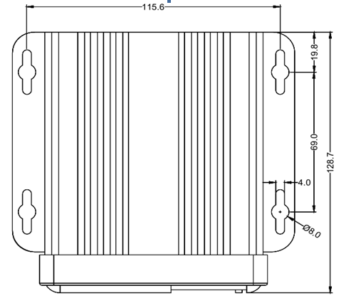

There are two ways to install the host: horizontal installation and side installation:
1. Horizontal installation: place the machine flat on the mounting surface, and fix the machine on the mounting surface by aligning four fixing holes of the machine foot with screws;
2. Side installation: when the machine cannot be installed horizontally due to space limitation, side installation can be adopted, such as mounted on vertical wall or side of bus. When installing from the side, install according to the icon on the back panel of the host.

5.5 Power cord connection
The vehicle-mounted video recorder USES dc power input, and the input voltage normally works in a range of +8V ~ +36V.
- The indicator diagram of using the ignition switch to control the delay operation of the on-board video recorder is shown below:
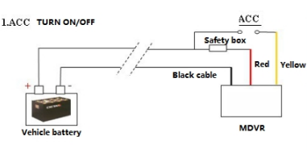
- An example of the main brake connection (video recording of the main brake control switch) is shown in the following figure:
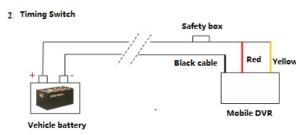

5.6 Alarm input connection
The device has 4 groups of digital alarm input interfaces. Alarm input detection is level detection, which can connect to various vehicle driving conditions, such as braking, steering horn and so on. The brake detection diagram is shown in the figure below. When the brake pedal is depressed, the device can detect a high level, otherwise it can detect a low level. The connection method is shown in the following figure:
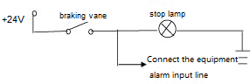

Optional:

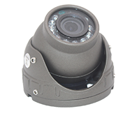 | 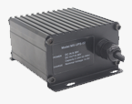 | 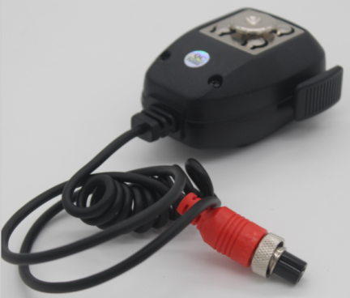
Camera | UPS | Hand held microphone
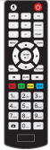 | 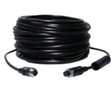
Remote controller | Extension cable(3m,5m,10m)

MDVR operation guide

6.1 Remote Controller
Key | Function | Image
[0-9] | [0-9] keys: In the setting status, the numeric keys are used for number selection. During playback, keys 1, 2, 3 and 4 are used for switching between single window of channels 1-4, key 0 is used for switching to synchronous playback of 4 channels.
[DEL] | Backspace when inputting numbers.
[RETURN] | Exits to the preview menu or returns to the parent menu.
[ENTER] | Confirms parameter selection and settings as well as operations like play.
▲, , , | Arrow keys that move the cursor upward, downward, leftward and rightward.  The left and right keys are used for increasing and decreasing the volume during surveillance playback.  - Fastback, 2x/4x/8x/16x for selection, press once to switch to the next speed in order, press [Play] to resume normal speed;  - Fast-forward, 2x/4x/8x/16x for selection, press once to switch to the next speed in order, press [Play] to resume normal speed;
 | Perform 4-screen picture capture function
 | Input dot character, such as ip “192.168.1.1”
 | Control external pan/tilt
+ | Can enter the test interface, view module information, etc., easy to debug.
Others | Function retention button.

6.2 Real-time preview interface
The real-time preview interface of the camera does not carry out any operation and superimposes different OSD information in the three regions:

The top left corner shows the system time information, the top right corner shows some status ICONS of the device, and the bottom area shows some peripheral access information. Icon status means the registration platform, GPS positioning, 4G dialing, SD card video recording and HDDD video recording from left to right. Common icon status includes:

Successful registration platform
Registration platform failed
GPS positioning successful
GPS location failed
The 4G module does not exist
The SIM card does not exist
Successful 4G dialing
SD card does not exist
The SD card exists and records video. Please ask the supplier for detailed documentation of the icon for other status. The icon status can be hidden by pressing the remote control del key.

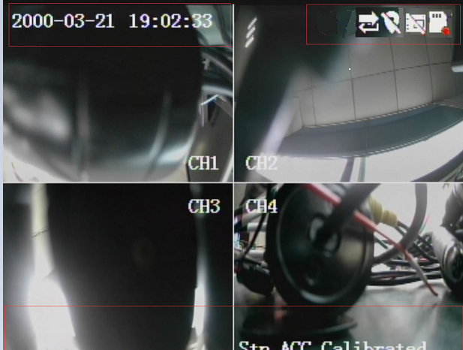

6.3 Menu diagram
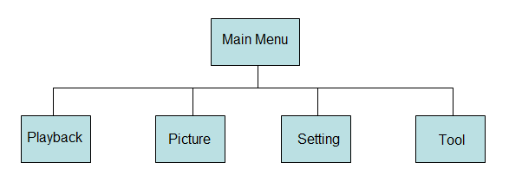

6.4 Login
- When password is set DISABLE, Press【ENTER】key on the remote controller into the main menu directly.
- When password is set ENABLE, Press 【ENTER】key on the remote controller into the login menu as below, enter the correct user name and password, then press【ENTER】key into the main menu.
- Default user name: admin. Administrator default password is “999999”,

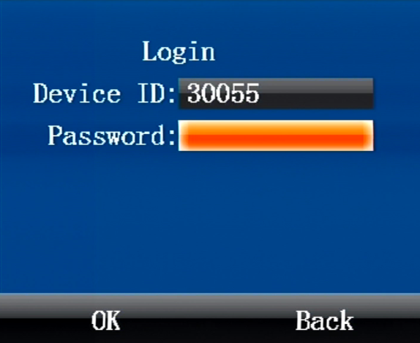

6.5 Main Menu
After login successfully, enter the main menu as below. It includes 4 items: Playback, Preview, Settings, Tools.
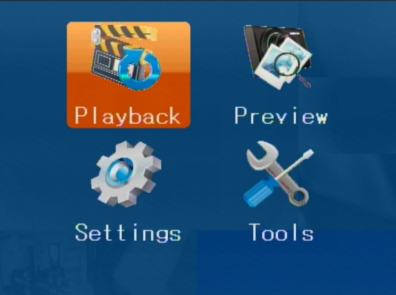

6.6 Playback (secondary menu)
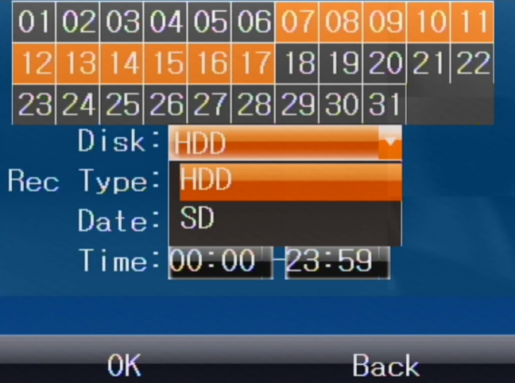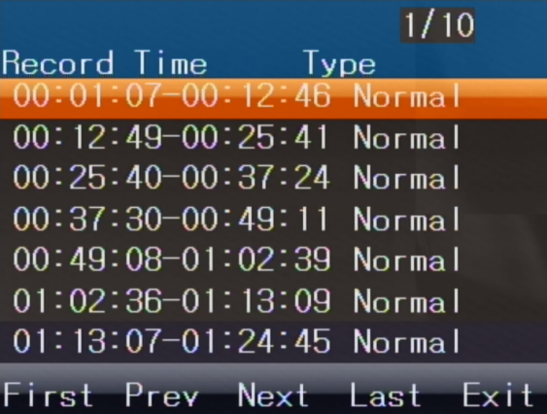
Press the arrow key to select the video material you want to view, and then press [ENTER] to start playing the video material.

6.7 Pictures (secondary menu)
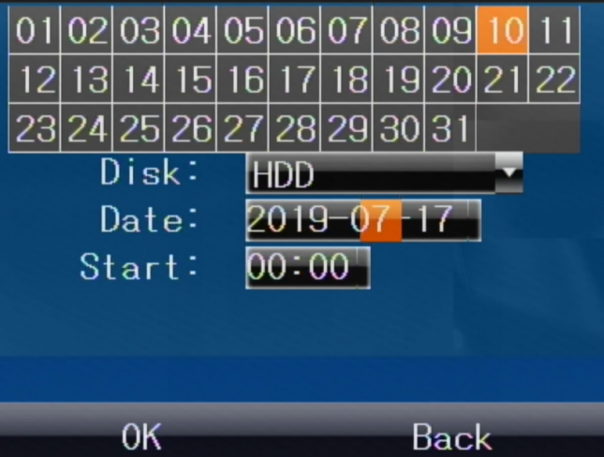
The date box is marked yellow to indicate a photo file taken that day.

6.8 Settings (secondary menu)
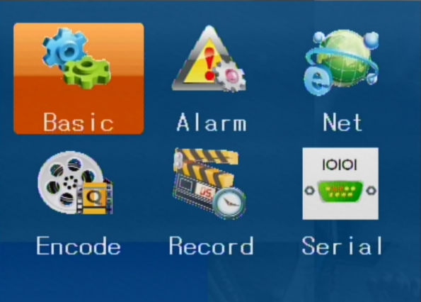
System Settings mainly include the following menu：
Basic Settings、alarm Settings、 network Settings、coding Settings、 video Settings、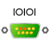Serial port setup.

6.8.1 Basic setup
Set up the basic information of the system, including 5 three-level menus:

Time:
Used to set the system time-related parameters of the device, including date, time, time zone, and timing
Password:
For setting user menu operation security control, login password, etc
User:
The owner information used to set up the equipment, such as the equipment number, information about the installed vehicle, and external UPS opening and closing
Mirror:
Used to set 1-4 channel video mirroring mode
Switch machine:
Used to set the device's on-off mode, ACC mode shutdown delay, ACC off whether to open or not continue to open the camera recording.
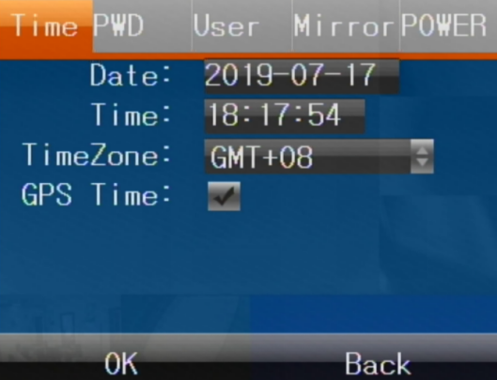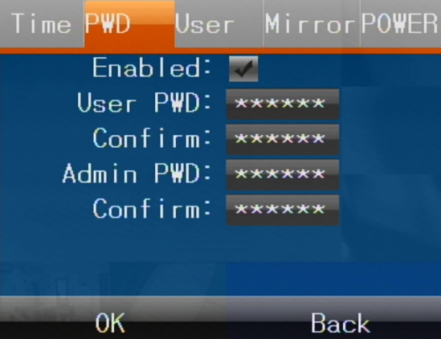
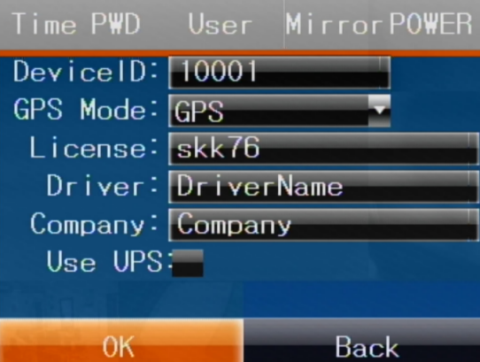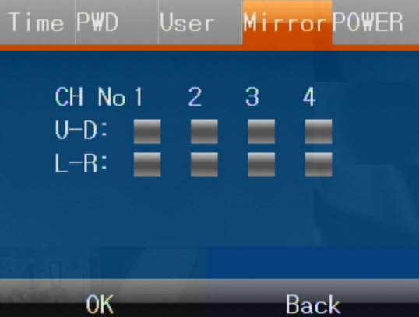
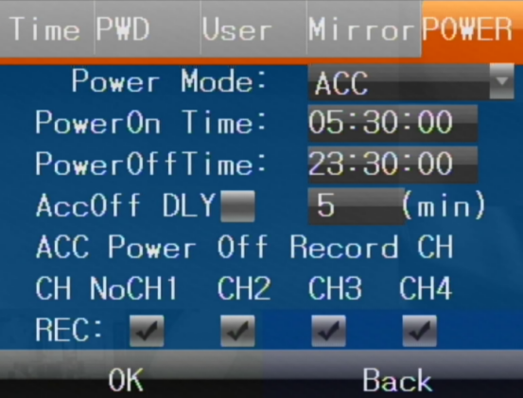

6.8.2 Alarm set
Alarm setting, including 5 three-level menus:

Basic:
This menu is configured with the alarm input parameters of the equipment, such as: oxygen alarm, combustible gas alarm peripheral threshold and other parameters configuration

Input:
This menu opens configuration 4 IO alarm input, 1 ADC analog input related parameters

Output:
This menu configures the parameters of alarm output function

Linkage:
This menu is configured with 4-channel alarm input, overspeed and GSensor function linkage alarm

Acceleration:
This menu is used to set the opening and check the Gsensor value. Gsensor static calibration
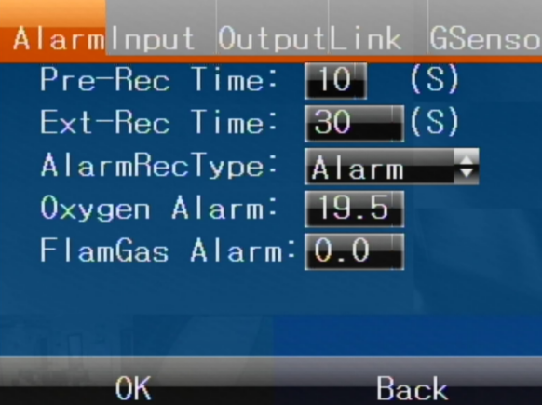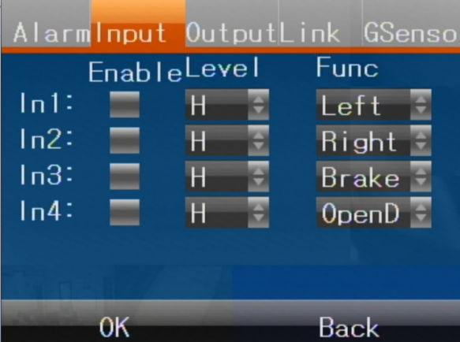

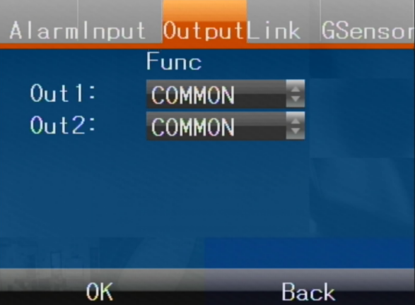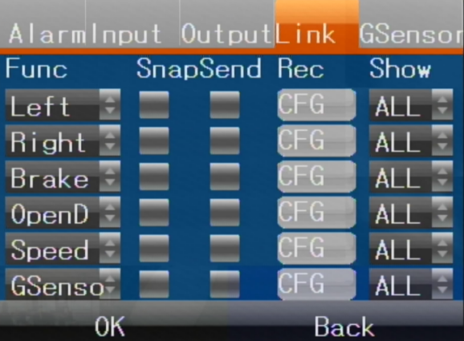
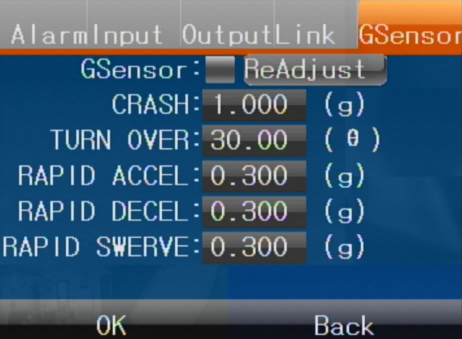

6.8.3 Network Settings
This column sets the network-related parameters of the device, including 7 sub-items:

Mode:
It is used to set parameters such as device network mode, GPS data upload platform interval, and the ministry standard function is turned on and off
Center:
Used to set the device connection server related parameters configuration, support IP and domain name way to connect to the server
Three-quarters of g:
Used to set parameters such as device type 3/4g

Network:
Used to set parameters related to the local IP address of the device. IP address 2 is the IP address parameter of the model with built-in ADAS function (temporarily unavailable).
PTT:
Used to set device connection PTT server open and related parameter configuration
808:
Use to set the configuration of the parameters associated with the connection ministry server
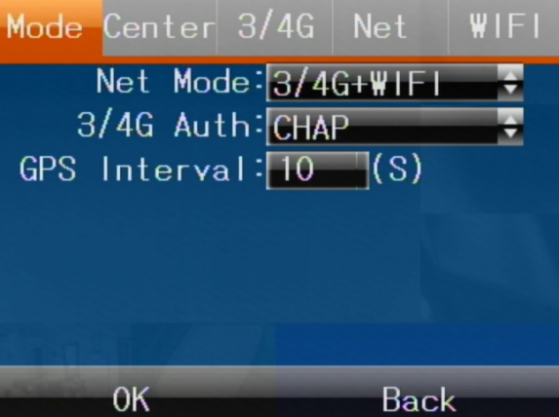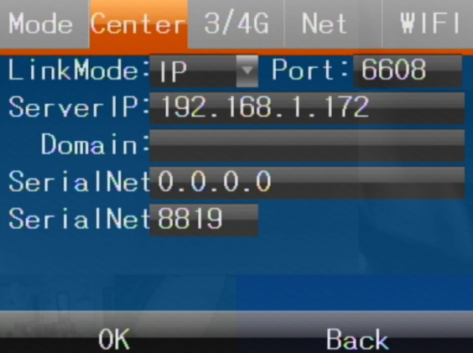
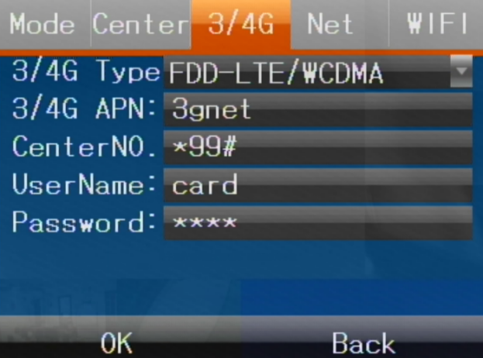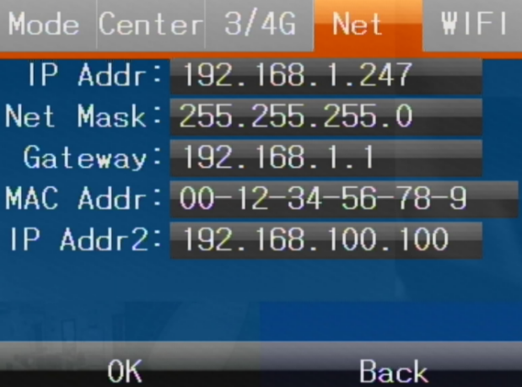
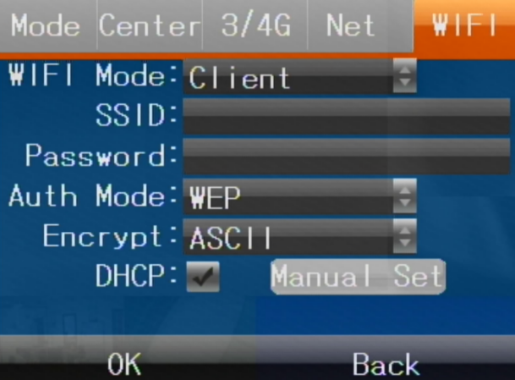

6.8.4 Encoding setting
Set the encoding, including three three-level menus:

The main stream:
Used to select 1080P, 720P, D1 resolution type, audio and video on, image clarity 1080P is the best, D1 is the worst

Subcode flow:
Used to select encoding mode clarity, image quality and other parameters

OSD:
Used with superimposed license plate, device number and other parameters
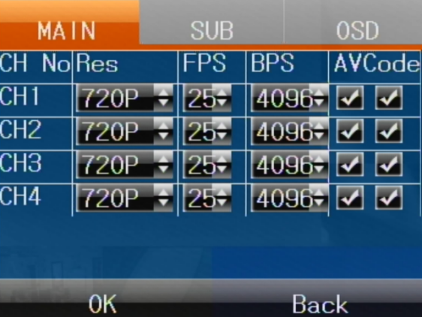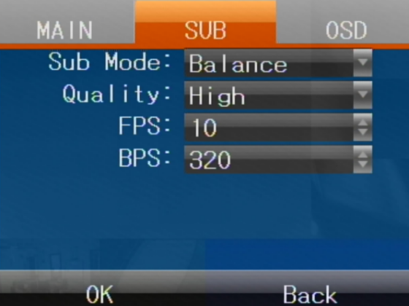

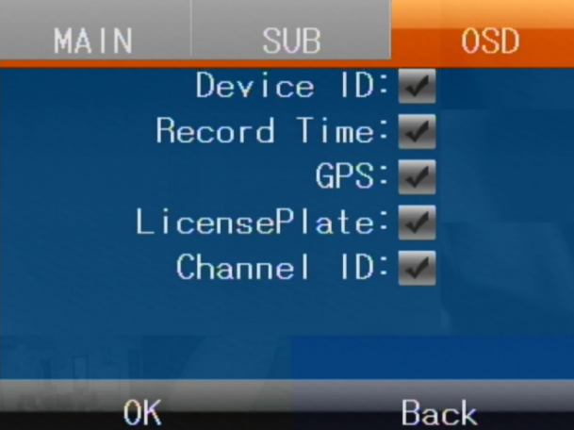

6.8.5 Video Settings
This column sets the camera type, video mode and encoding type, image capture and other related parameters, including four three-level menus

Camera:
The default video system PAL system, can be equipped with NTSC system, can freely configure any combination of cameras to support 1080P, 720P, 960H resolution camera

Video:
The default video coding format is H264, which can be equipped with H265 format. Relevant parameters such as video recording mode and SD card usage can be set

Timing:
To set the timing recording, the recording mode should be changed to the timing recording, and the recording state should be modified in the recording. The timing recording configuration of two groups of time periods is supported, and the flexible configuration of any day and every day is supported

Capture:
Set the number of days for the snapshot to be saved automatically, and the pictures exceeding the number of days will be deleted automatically. The snapshot duration can be configured from 1 to 30 days, with the default frequency of 7 days and 300s

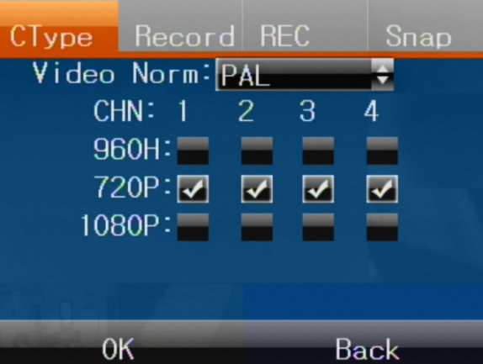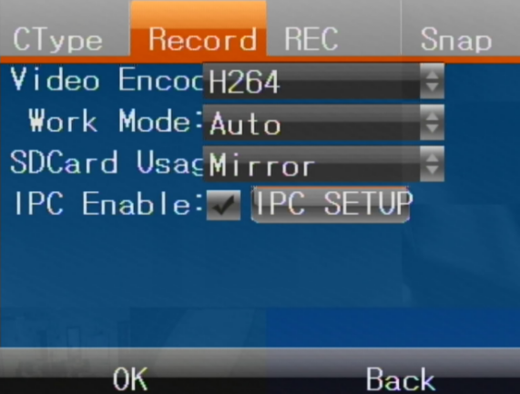
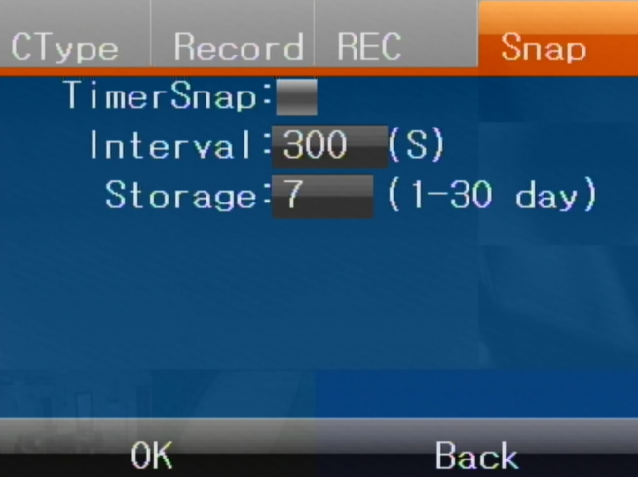

6.8.6 Serial port Settings
This column sets two three-level menus for configuration of peripheral parameters of serial port, one four-level menu for configuration of serial port box, and five five-level menus for configuration of serial port box

Serial peripherals:
The device comes with two serial ports, RS232 and RS485, which support the external serial port box to expand the serial port. The maximum support for 6 serial ports is RS232x5(a serial box occupies one)+RS485x2. Our serial port cartridge has 4 RS232, 1 RS485 serial port, 2 ADC and other extended ports. For details, please ask the supplier for the serial port box specification document
Equipment with RS232 and RS485 serial port can match serial braket, passthrough peripherals sensors, temperature sensors, oil, etc., need to use a serial port extension box, in the first serial interface (RS232 serial port function configured for serial box function, configuration button grayed do not match or serial box, enter the serial box serial port configuration level 4 menu box related peripheral configuration.

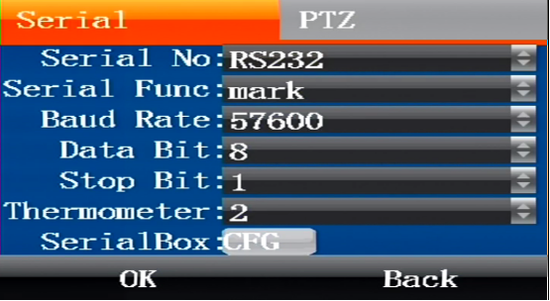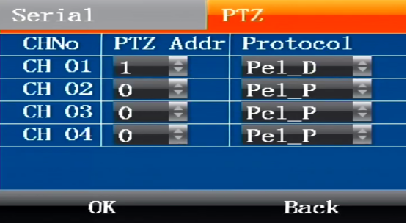

6.8.6.1 Serial box configuration
Serial box peripherals:
This menu includes five menu bars of serial port function configuration, extended input, extended output, ADC and linkage

Serial port:
Serial port head, transmission, temperature sensor, oil sensor and other peripherals related parameter configuration

Extended input:

Open the configuration serial port box and input 4 IO alarm parameters

Extended output:
This menu includes two functions:

Alarm output:
Configure serial box alarm output function parameters

PWM pulse:
Configuration of serial port box PWM related parameters, PWM mode can be selected for input and output mode. Example: input mode duty cycle, frequency parameters are not matched, access to the pulse peripheral device to receive data and display. Output mode configuration duty cycle, frequency parameter access pulse detection peripherals will display the pulse data according to the configuration

The ADC:
ADC1, ADC2 extension port related parameters are configured, alarm input, temperature, oil volume and other functions are optional, which will be turned off if not used. Example: ADC1 is connected to the analog temperature sensor, and the voltage collected by the device is converted into temperature data according to the rules and displayed on the device and the platform.

Linkage:
Configure the corresponding serial box 4 way alarm input linkage alarm related parameters

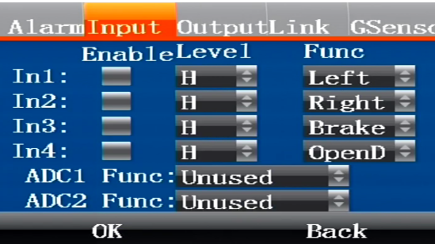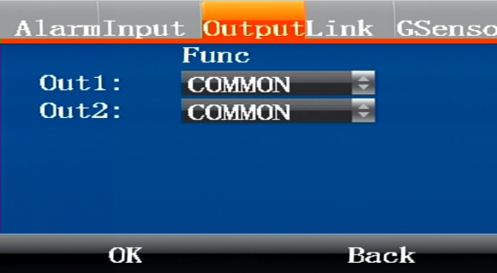

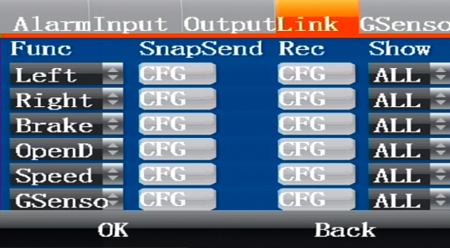

holder：
Relevant parameter configuration is carried out when accessing the cradle head peripherals
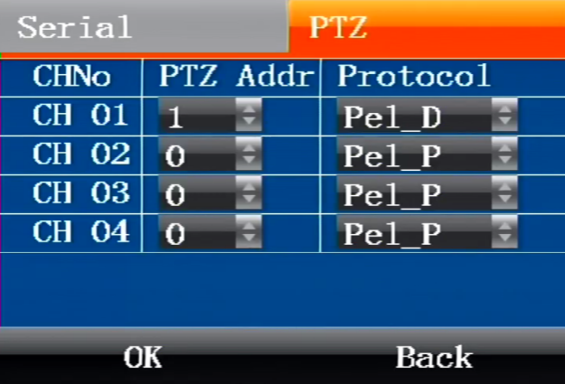

6.9 Tools (secondary menu)
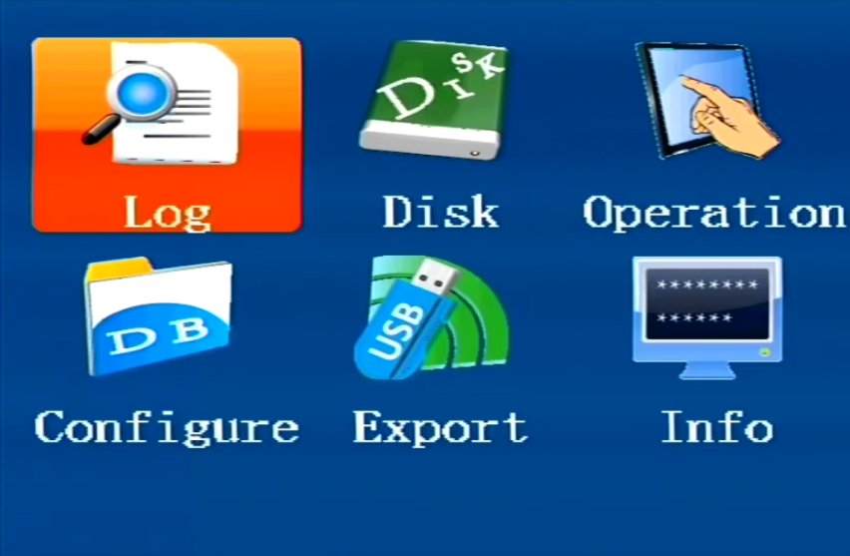
Management tools mainly include the following submenu:
Log management
Disk management
Operation management
Configuration management
Export data
System information.
This column sets the network-related parameters of the device, including 6 sub-items:
Log management:

Log management mainly provides users with the important records of the daily operation of the equipment, including: on/off machine, GPS calibration, alarm, system upgrade and other event information, including event date, event time and event name.

Disk management:
Used to view disk capacity and format disk and external usb drive capacity information
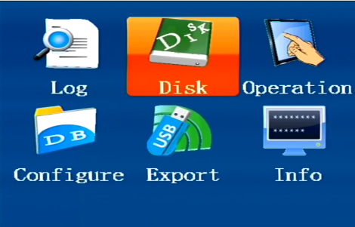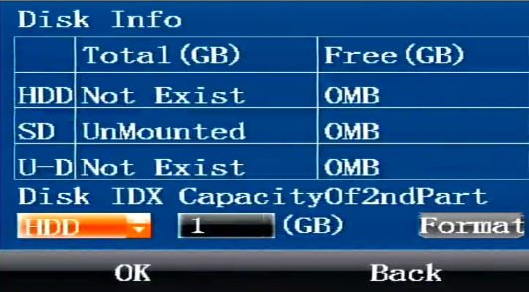
Operation management:
Used for setting menu stay time, device language, and device restart button.

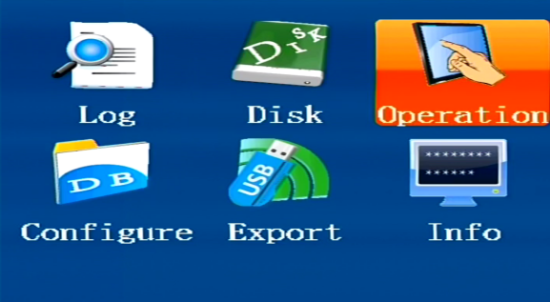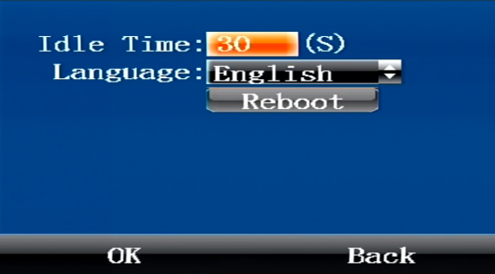
Configuration management:
Used for device parameter export and import, G-sensor parameter value export
Data export:
For video file export, you can select disk location and file time to intercept the export

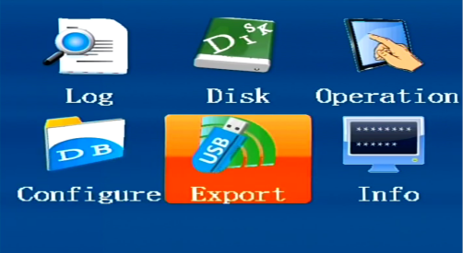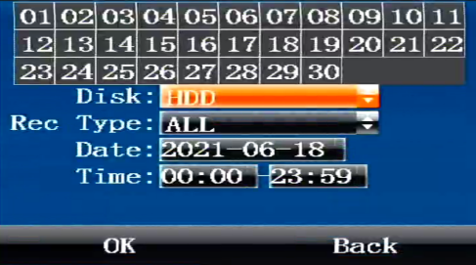
System management:
Display device firmware number information

Answers to frequently asked questions
Q: why is the device still unable to start after receiving power?
Reason 1: the supply voltage does not reach 8-36v or the power does not reach more than 50W.
Reason 2: the SD card lock is not closed.
Reason 3: the connection mode is not correct, please refer to 1.3 power connection mode.
Reason 4: motherboard or power hardware failure, please contact the supplier.

Q: why didn't the 3G/4G dialing work?
Reason 1: the device does not turn on 3G/4G dialing. If it is a 3G VPN private network needs to set up APN, dial number, user name and password.
Reason 2: the device's 3G antenna is not connected properly.
Reason 3: the SIM card is down or the 3G /4G service is not enabled.

Q: why are devices still unable to connect to the platform when connectivity to the mobile network has been successful?
Reason 1: the server IP, device ID number and other platform login parameters are not set correctly.
Reason 2: the platform server is not running normally. Please check whether the database service and other components of the server are running normally.

Q: why is satellite location information not available?
Reason 1: the satellite positioning signal can only be obtained outside. Please confirm whether the antenna is outside.
Reason 2: check if the antenna is inserted and if it is in the wrong position.
Reason 3: view the star value of the information interface and contact the manufacturer.

